Rotorua District Schools Group Day
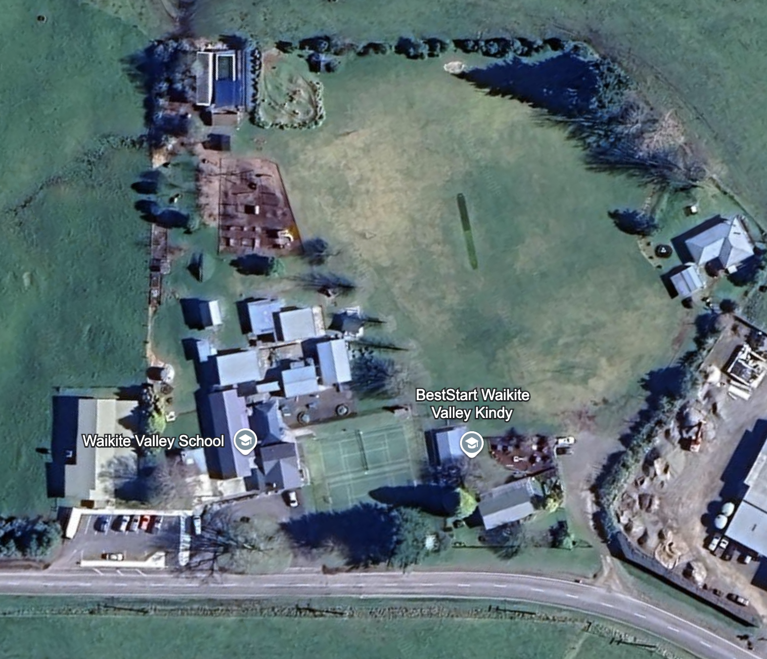


2026

ROTORUA DISTRICT SCHOOLS GROUP DAY 2026
Hosted by Waikite Valley School

PROGRAMME
- 9:30 am Morning Tea & Briefing for Judges and Stewards
- 10:00 am Judging Commences (10am Sharp)

JUDGING ORDER

CHAMPIONSHIP RINGS
1. -Leading
-Champion Leading
-Reserve Champion Leading
2 -Calling
-Champion Calling
-Reserve Champion Calling
3 -Care and Attention – (judged outside the ring concurrent with above)
-Champion Care and Attention
-Reserve Champion Care and Attention

OPEN RING
- Leading
- Calling
- Care and Attention – (judged outside the ring concurrent with above)

- 12:45 pm approx - Lunch
- 1:15 pm approx - Team Marching
- 1:45 pm approx – Prizegiving

CHAMPIONSHIP RING ALLOCATIONS
- Ring 1 Junior Lambs
- Ring 2 Intermediate Lambs
- Ring 3 Senior Lambs
- Ring 4 Junior Calves
- Ring 5 Intermediate Calves
- Ring 6 Senior Calves

PLEASE NOTE:
- There will be no re-runs
- Judge’s decision will be final
- First place getters only will be judged for champion event in each section, second place getters to stand by for judging of Reserve. Only the second-place getter to the champion is considered for Reserve Champion, along with the two other first place getters already judged
- Shields and entries are to be handed in at the registration desk on arrival.
- There will be food and drinks for sale by Reporoa Primary School (cash only)

IMPORTANT NOTICES
Parking in the paddock is across the road from the school on Settlers Road, use this rather than parking on the roadside – follow the signs!
Animals are to be unloaded and walked across the road. Calves will be checked for TB cards and lice prior to coming over to the school.
Only children with animals and officials are permitted behind the rings after 9.45 am
All children will be actively supervised and cared for, please ensure they are well equipped for at least 3 hours, they require:
Food and drink - Sunhat and sunscreen - Warm clothing and raincoat. Reporoa Primary School encourage all schools to bring their own gazebos. There is water available at the back of the pens. for your animals from a hose near the swimming pool.
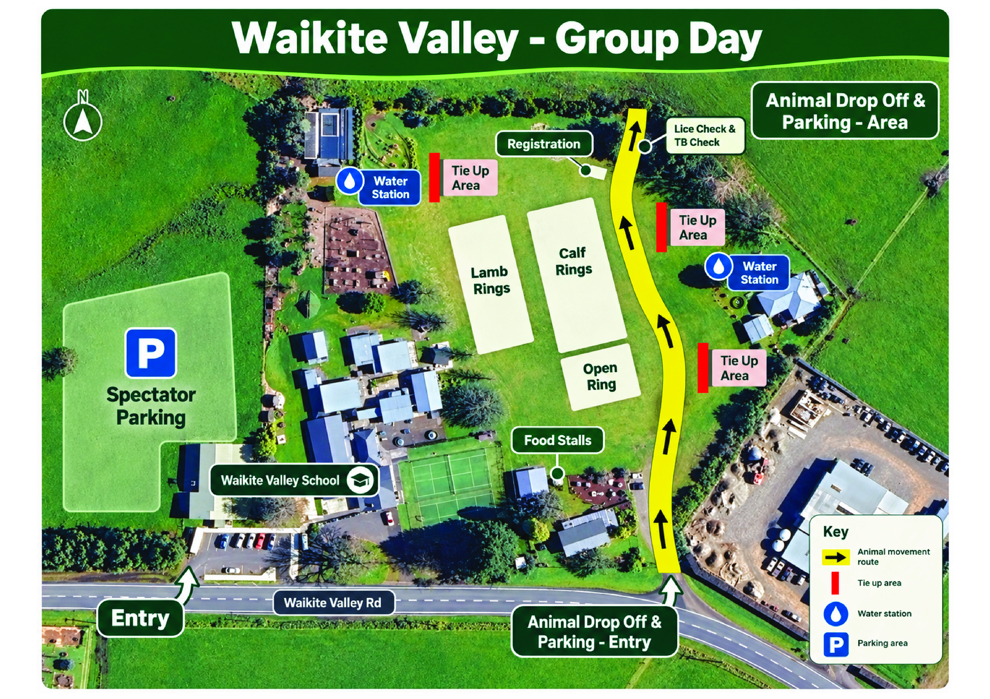

ROTORUA DISTRICT SCHOOLS COMPETING:
Galatea Black 1-20
Reporoa Green 21-40
Lake Rerewhakaaitu Blue 41-60
Ngakuru Red 61-80
Waikite Valley Maroon 81-100
Mihi Orange 101-120
Broadlands Purple 121-140
Kaharoa Gold 141-160
Mamaku White 161-180
Upper Atiamuri Pink 181-200
Wairakei Silver 201-220

GOOD LUCK ALL COMPETITORS, HAVE A GREAT DAY!

BIG THANK YOU TO OUR SPONSORS FOR THEIR SUPPORT




